1. Unzip the sample zip file to your disk drive on your Windows PC where you have Alibre Design intstalled
2. Open the .NET Framework C# solution named ‘AlibrePdmApiSample.sln’ in Visual Studio (Note: this was saved and tested last using Visual Studio 2022)
3. In Solution Explorer, under ‘AlibrePdmApiSample' project, navigate to the 'References' tree branch. You may notice that the reference to 'AlibreX' .NET assembly is broken. Delete this reference.
Then, right click on 'References' and select 'Add Reference..'. Browse to the 'Program' sub-folder under the folder where you installed Alibre Design. Locate AlibreX.dll in that sub-folder and select it. In a typical installation, this would be “C:\Program Files\Alibre Design\Program\AlibreX.dll”.
4. Build ‘AlibrePdmApiSample' project in Release/x64 configuration. This will create ‘AlibrePdmApiSample.exe' under ./bin/x64/Release
5. Make sure to close Alibre Design application if it is running. Then launch the sample application ‘AlibrePdmApiSample.exe'. This will open a form as shown below:
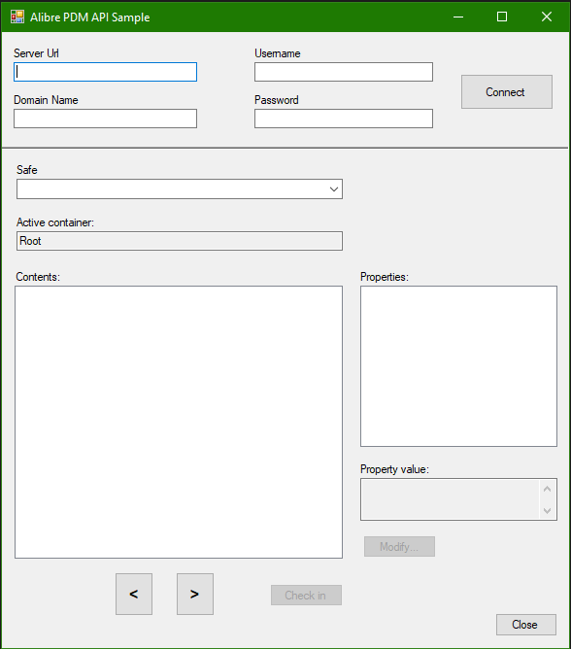

6. Enter the URL of the computer where your PDM Server is installed. Example: http://192.168.1.1:8099
7. Enter the Domain Name of your PDM Server. Example: MyPDMServerPC
8. Enter login credentials and click on the ‘Connect’ button
9. If the information provided is valid, the combo-box named ‘Safe’ will list the Safes available on your PDM server. Select the Safe you want to connect to
10. At this point the program should display the contents (folders and files) present on the selected safe
11. You can double click on a folder to navigate to it and see its content. You can use ‘<’ and ‘>’ buttons at the bottom of the dialog also to navigate forward and backward
12. Clicking a file in the ‘Contents’ list will display its properties in the ‘Properties’ list box. Clicking a property here will display its value assuming one is present. You may then click the ‘Modify’ button to change its value. Modifying a property value will cause the ‘Check in” button to get enabled. Clicking this will submit the modified file to the safe creating a new version of the file
8. You may then explore the sample application code to understand the AlibreX api calls employed. It is suggested that you put a debug break point at “MainForm_Load” and other event handler methods in ‘MainForm.cs’ and step through the code in a Visual Studio debugger session.

